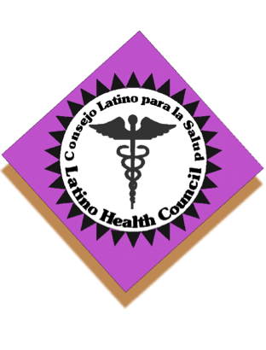
Latino Health Council

UW Health at The American Center

Room 1660 (east end of the first floor Specialty Clinic)

September 22, 2016
9:30-11:30

0. Continental breakfast

1. Introductions

2. Minutes (approval/corrections)

3. Announcements/check-in

4. Old business:

- LCA/UNITED WAY: Dane County’s Latino community call to action

- 2017 list of meeting places/minutes takers

- Health fair planning

- Subcommittees’ meetings/updates:
  - Finances
  - Membership
- Website

5. New business:

- UW Health (Presentation)

Meeting adjourned

Next meeting: October 27, 2016

Meeting place: Dean/SSMH Location TBA

Minutes: UNIDOS??

